**Question Number 6:**

**PROGRAM:**

#include <iostream>

using namespace std;

class Account

{

public:

Account() // constructor if parameter is not passed

{

balance = 0;

}

Account(int a) // construtor if parameter is passed

{

balance = a;

}

int balance;

void withdraw(int a) // withdrawing money

{

if (balance >= a)

{

cout << endl << "Your current balance is : " << balance;

balance = balance - a;

cout << endl << "After withdrawing money, you balance remains : " << balance;

}

else

cout << "Your current balance is less than withdrawing money, access denied !";

}

void add(int a) // adding the money

{

cout << endl << "Your current balance is : " << balance;

balance = balance + a;

cout << endl << "After adding money, your balance becomes : " << balance;

}

void CB() // current balance

{

cout << "Your current balance is : " << balance;

}

};

int main()

{

int a;

cout << "Enter the amount of balance you want : ";

cin >> a;

Account obj1(a);

cout << endl;

int opt; // using switch case

cout << endl << "Press 1 to see your current balance ";

cout << endl << "Press 2 to add money to your current balance ";

cout << endl << "Press 3 to withdraw your money ";

cout << endl << "Opton used : ";

cin >> opt;

switch (opt)

{

case 1:

{

obj1.CB();

break;

}

case 2:

{

cout << "Enter the amount you want to add : ";

cin >> a;

obj1.add(a);

break;

}

case 3:

{

cout << "Enter the amount you want to withdraw : ";

cin >> a;

obj1.withdraw(a);

break;

}

default:

cout << "Invalid Entry!";

}

cout << endl << endl;

system("pause");

}

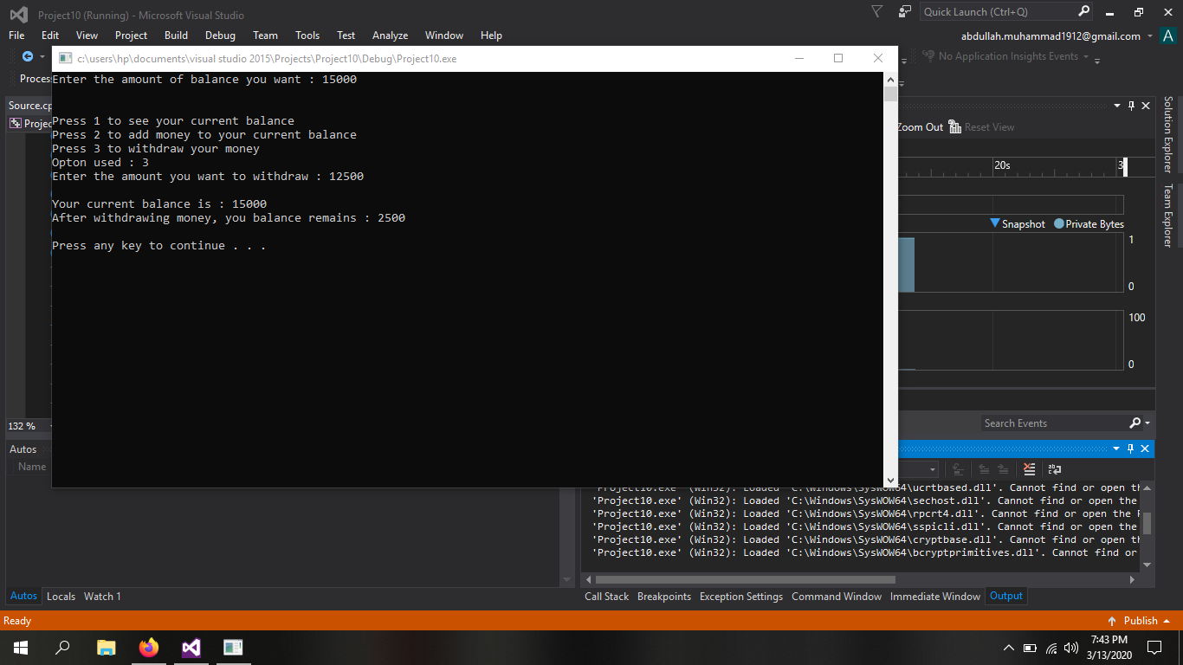

**Question Number 7:**

**PROGRAM:**

#include <iostream>

using namespace std;

class Employee

{

public:

Employee()

{

name[25] = 0; mobile_number[15] = 0, emp_id[15] = 0;

}

class DOB { // DOB nested class

public:

DOB()

{

Date = 0, Month = 0, Year = 0;

}

void setter();

void getter();

private:

int Date;

int Month;

int Year;

};

void setter();

void getter();

private:

char name[25];

char mobile_number[15];

char emp_id[15];

};

void Employee::setter()

{

cout << "Enter the name of Employee : ";

cin >> name;

cout << "Enter the Mobile number of Employee : ";

cin >> mobile_number;

cout << "Enter the ID of Employee : ";

cin >> emp_id;

}

void Employee::DOB::setter()

{

cout << "Enter the Date of Birth of Employee : ";

cin >> Date;

cout << "Enter the Month of Birth of Employee : ";

cin >> Month;

cout << "Enter the Year of Birth of Employee : ";

cin >> Year;

}

void Employee::getter()

{

cout << "The name of Employee is : "<<name<<endl;

cout << "The Mobile number of Employee is : "<<mobile_number<<endl;

cout << "The ID of Employee is : "<<emp_id;

}

void Employee::DOB::getter()

{

cout <<endl<< "The DOB of Employee is : " << Date << " / " << Month << " / " << Year;

}

int main()

{

Employee obj1;

Employee::DOB obj2;

obj1.setter();

obj2.setter();

cout << endl;

cout << "Information about the Employee is : " << endl<<endl;

obj1.getter();

obj2.getter();

cout << endl << endl;

system("pause");

}

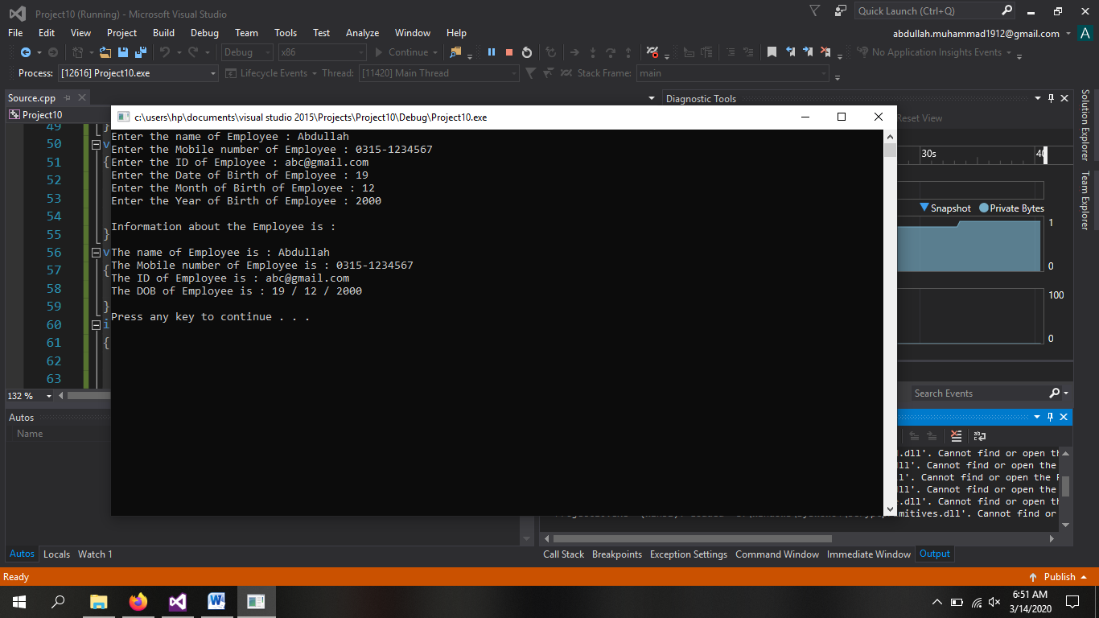

**Question Number 8:**

**PROGRAM:**

#include <iostream>

using namespace std;

class Car

{

public:

Car()

{

a = 0;

}

Car(const Car &obj) //deep copy

{

a = obj.a;

ptr = new int;

cout << endl << "Value of pointer is : " << *ptr;

}

void info() // inputting value

{

cout << "Enter value of variable : ";

cin >> a;

cout << "Enter value of Pointer : ";

ptr = new int;

cin >> *ptr;

}

void data()

{

cout << endl<<"Value of variable is : " << a;

cout << endl << "Value of pointer is : " << *ptr;

}

void Delete()

{

delete ptr;

ptr = NULL;

}

int a,*ptr;

};

int main()

{

Car obj1;

cout << "1st obj has been created"<<endl;

obj1.info();

obj1.data();

cout << endl;

Car obj2(obj1);

cout <<endl<< "2nd obj has been created" << endl;

obj1.Delete();

cout << endl << "Value of 2nd obj !" << endl;

obj2.data();

cout << endl << endl;

system("pause");

}

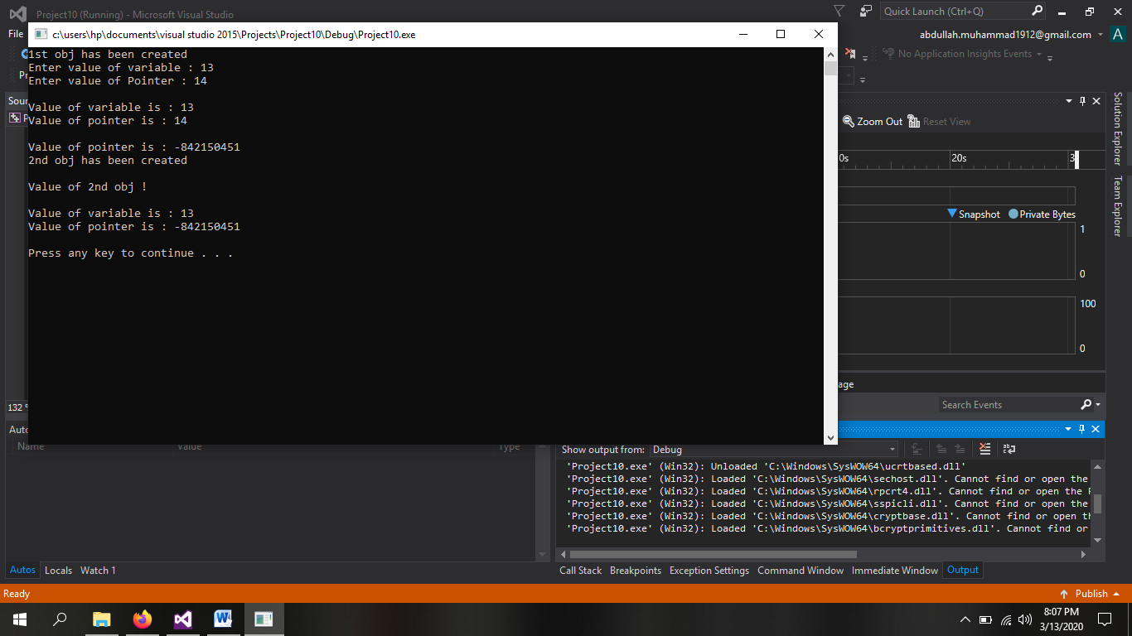

**Question Number 9:**

**PROGRAM:**

#include <iostream>

using namespace std;

class TollBooth

{

public:

TollBooth()

{

no_of_vehicle = 0, Total_amount = 0;

}

void amount(int a,int b,int c)

{

cout << endl << "Total amount collected from car is : " << a;

cout << endl << "Total amount collected from hiace is : " << b;

cout << endl << "Total amount collected from bus is : " << c;

Total_amount = a+b+c;

cout << endl<<"Total amount collected is : " << Total_amount;

}

void vehicle(int a, int b)

{

cout <<endl<< "Total Number of vehicles which were paid are : " << a;

cout << endl << "Total Number of vehicles which were non-paid are : " << b;

no_of_vehicle = a + b;

cout << endl << "Total Number of vehicles are : " << no_of_vehicle;

}

private:

int no_of_vehicle;

int Total_amount;

};

int main()

{

int p=0,n=0;

char a;

TollBooth obj;

cout << "Press P for paying vehicles and N for non paying vehicles " << endl;

for (int i = 0; i < 10; i++)

{

cout << "Vehcile " << i + 1 << " is : ";

cin >> a;

if (a == 'p' || a == 'P')

p++;

else if (a == 'n' || a == 'N')

n++;

else

cout << "Invalid Entry for vehicle " << i + 1 << " !";

}

cout << endl;

cout << "Amount for paying vehicles : " << endl;

cout << "Press 1 for car " << endl;

cout << "Press 2 for hiace " << endl;

cout << "Press 3 for bus " << endl;

int opt,car=0,bus=0,hiace=0;

for (int i = 0; i < p; i++)

{

cout << "Option choosed : ";

cin >> opt;

if (opt == 1)

{

car++;

}

if (opt == 2)

{

hiace++;

}

if (opt == 3)

{

bus++;

}

}

car = car * 20;

hiace = hiace * 50;

bus = bus * 100;

obj.amount(car, hiace, bus);

cout << endl;

obj.vehicle(p, n);

cout << endl << endl;

system("pause");

}

